- Found flag to turn on viewing the result, got this for my hcp_anatomy_egi.m with local full head T1
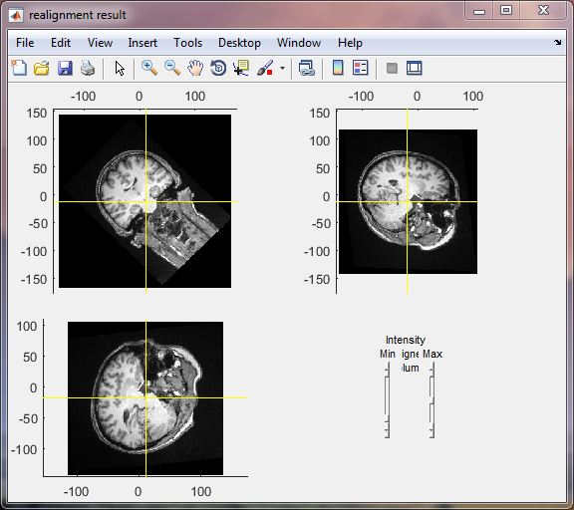

- Next tried to use original hcp_anatomy with local T1 (same T1 as above) and got similar 45 degree rotation
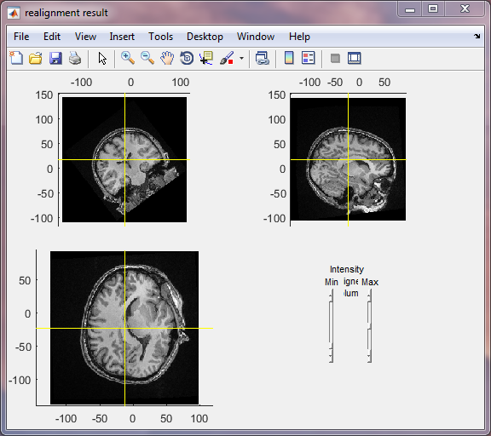

- Now to try downloaded example T1 with original hcp_anatomy -> same thing, does not make sense
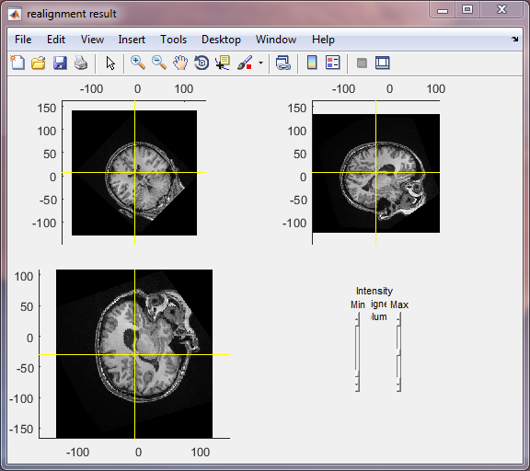

Brainstorm import of first case above (third case above displays correctly upon import)
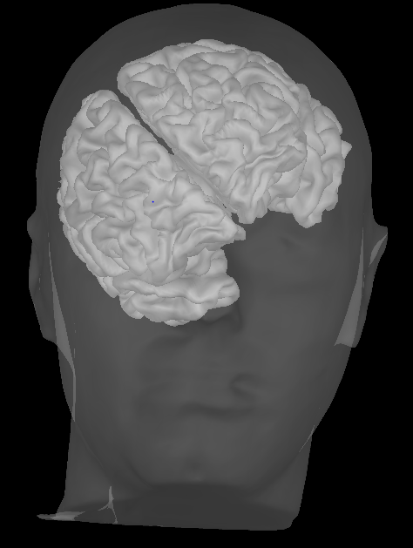
This is the result of headshape registration, which seems correct (HCP figure)
